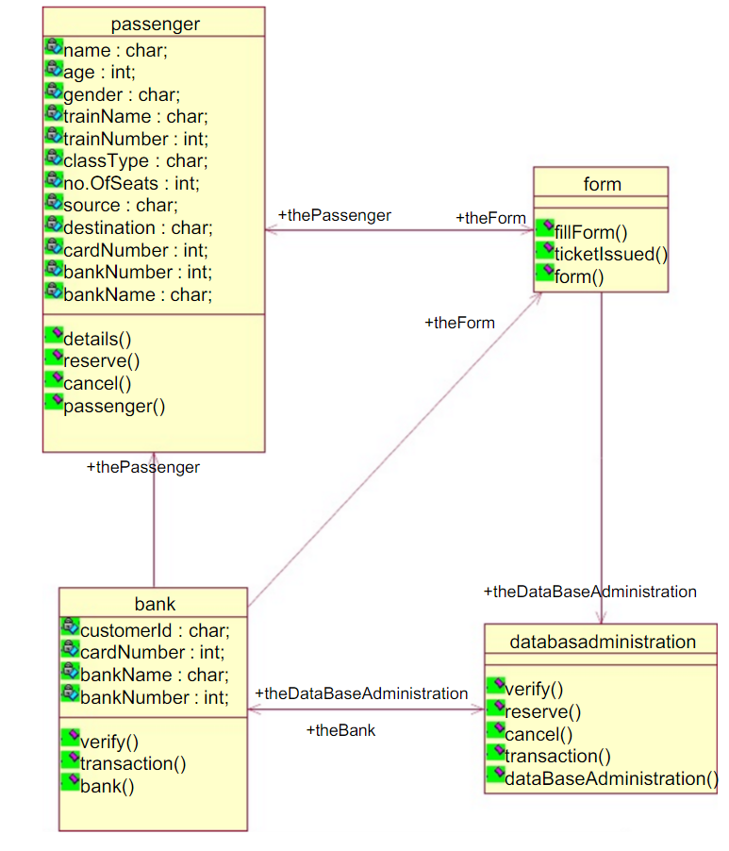

**UML DIAGRAM FOR ETICKETING SYSTEM**

**F**